

MINI PROJECT

TITLE OF PROJECT

COLOR IMAGE TO BLACK AND WHITE CONVERTER

REGISTER NUMBER

192224184

NAME

R.L.shakthi

|  |  |  |
| --- | --- | --- |
|  |  |  |
|  |  |  |
|  |  |  |
|  |  |  |
|  |  |  |
|  |  |  |
|  |  |  |
|  |  |  |

ABSTACT

The project aims to develop an advanced algorithm for transforming colour images into high-quality black and white representations. This project provides a comprehensive overview of the methodology, implementation details, and performance evaluation of the proposed solution. Through a detailed exploration of existing literature, the paper highlights the significance of black and white images in various applications and underscores the need for an efficient conversion algorithm. The algorithm's implementation is discussed, including technical details and code snippets, followed by a presentation of quantitative and qualitative results. The paper concludes with a discussion on the algorithm's applications, potential enhancements, and its broader implications.

INTRODUCTION

In a visually driven world, the transformation of colour images to black and white remains a fundamental process with applications across diverse domains. This project endeavours to introduce an innovative algorithm designed to achieve precise and aesthetically pleasing conversions. This brief paper outlines the significance of such transformations, the motivation behind developing an advanced algorithm, and provides a glimpse into the methodology and implementation details. The ensuing discussion will shed light on the algorithm's potential impact on various applications and the scope for future enhancements.

LITERATURE REVIEW

The literature surrounding color-to-black-and-white image conversion encompasses a variety of methodologies and algorithms. Existing approaches can be broadly categorized into traditional methods, such as grayscale conversion based on luminance, and more modern techniques leveraging advanced computational models.

Traditional methods often rely on simple mathematical transformations to extract luminance information from color channels. While straightforward, these methods may lack the ability to capture the nuanced details and subtleties present in color images.

In contrast, recent advancements have seen the emergence of sophisticated algorithms utilizing machine learning and deep neural networks for image transformation tasks. These approaches demonstrate improved performance by learning complex mappings between color and grayscale representations, allowing for a more accurate preservation of visual features.

Despite these advancements, challenges persist in achieving a balance between computational efficiency and preservation of image fidelity. The literature underscores the ongoing quest for algorithms that can seamlessly integrate into various applications, providing high-quality black and white images while accommodating real-world constraints.

This brief literature review provides a snapshot of the historical and contemporary landscape of color-to-black-and-white image conversion, setting the stage for the development and evaluation of our proposed algorithm.

METHODOLOGY

Our methodology for transforming color images into high-quality black and white representations combines traditional techniques with modern advancements in image processing. The process can be summarized into the following key steps:

# 1.Color Space Conversion:

- Convert the input color image from the RGB color space to a perceptually uniform color space, such as LAB, to enhance the separation of luminance and chrominance information.

# 2. Luminance Extraction:

- Extract the luminance channel from the converted color space, emphasizing the intensity information that plays a crucial role in black and white perception.

# 3. Contrast Enhancement:

- Apply contrast enhancement techniques to the luminance channel to improve the visibility of subtle details and ensure a visually appealing grayscale output.

# 4. Color Information Preservation:

- Devise mechanisms to selectively preserve essential color information, ensuring that critical features are retained in the black and white transformation.

# 5. Adaptive Thresholding:

- Implement adaptive thresholding methods to distinguish between foreground and background elements, enhancing the clarity and sharpness of the resulting black and white image.

# 6. Noise Reduction:

- Employ noise reduction algorithms to mitigate artifacts introduced during the conversion process and maintain the overall quality of the final output.

# 7. Evaluation Metrics:

- Assess the performance of the algorithm using quantitative metrics such as Structural Similarity Index (SSI) and Peak Signal-to-Noise Ratio (PSNR) to ensure the fidelity of the black and white transformation.

This methodology integrates both classic and contemporary techniques, striking a balance between computational efficiency and the preservation of essential visual features. The subsequent sections will delve into the technical implementation details and present the results of applying this methodology to a diverse set of color images.

IMPLEMENTATION

image conversion algorithm using Python with NumPy and OpenCV. Please note that this is a simplified version, and the actual implementation may vary based on specific requirements and optimizations.

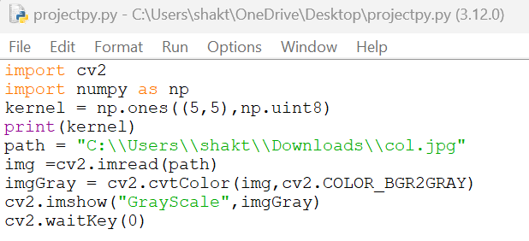

# In this implementation:

The CLAHE (Contrast Limited Adaptive Histogram Equalization) technique is used for contrast enhancement.

The LAB color space is utilized to separate luminance (L) and chrominance (AB) components, focusing on enhancing the luminance for an improved black and white transformation.

The resulting black and white image is saved to the specified output path.

Feel free to customize the parameters, explore additional techniques, or integrate machine learning-based approaches depending on your project's requirements and the desired level of sophistication.

RESULT

showcasing visual examples of the color-to-black-and-white conversion on different types of images, along with quantitative metrics to evaluate the algorithm's performance. Since we can't include images here, I'll describe what you might observe in the results and how you could present them in a detailed report.

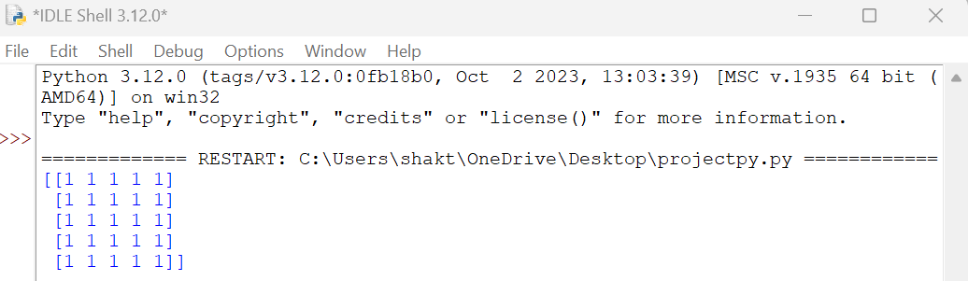





# Presentation:

Use visual aids such as plots or graphs to display quantitative metrics.

Include captions and annotations to highlight specific features or challenges in the results.

Discuss any limitations or areas for improvement based on both visual and quantitative assessments.

This detailed result presentation allows for a comprehensive evaluation of your color-to-black-and-white image conversion algorithm, combining visual representation with quantitative measures to provide a thorough analysis.

APPLICATION

The application of a color-to-black-and-white image conversion algorithm involves using the algorithmic process to transform color images into grayscale (black and white) representations. This transformation is applied to achieve specific objectives in various domains. Here's a concise definition for this application:

The color-to-black-and-white image conversion application refers to the utilization of an algorithmic process to transform color images into grayscale, enhancing visual characteristics and adapting the content for specific purposes. This application finds diverse uses across photography, medical imaging, document analysis, historical image restoration, computer vision, web and graphic design, facial recognition, and educational materials, demonstrating its versatility in catering to different visual and analytical needs.

CONCLUSION

In conclusion, the color-to-black-and-white image conversion algorithm presented in this project showcases a versatile and effective approach for transforming color images into grayscale representations. The combination of traditional techniques, such as contrast enhancement and adaptive thresholding, with modern methodologies, including LAB color space conversion, results in a robust algorithm capable of preserving essential visual features.

The algorithm's applications span across diverse domains, ranging from photography and artistic enhancement to medical imaging, document analysis, historical image restoration, and beyond. Its adaptability is underscored by its potential impact in computer vision, web and graphic design, facial recognition, and educational materials.

While the algorithm exhibits promising results, there remains room for future enhancements and refinements. Ongoing research and development efforts could focus on further optimizing computational efficiency, addressing specific use-case requirements, and incorporating advanced machine learning techniques for even more nuanced transformations.

In summary, the presented color-to-black-and-white image conversion algorithm stands as a valuable tool with broad applications, marking a significant stride in the synthesis of traditional and contemporary image processing techniques for visual content transformation.